Image | 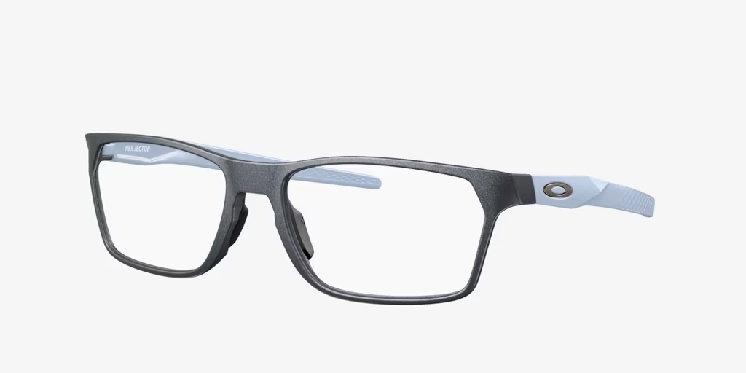
Brand | MICHEAL KORS
Model Name | OX8030 HEX JECTOR
Price | RS 1499
PRODUCT DETAILS

